**Inyoung Cho**

**Professor, Yonsei Univ.**

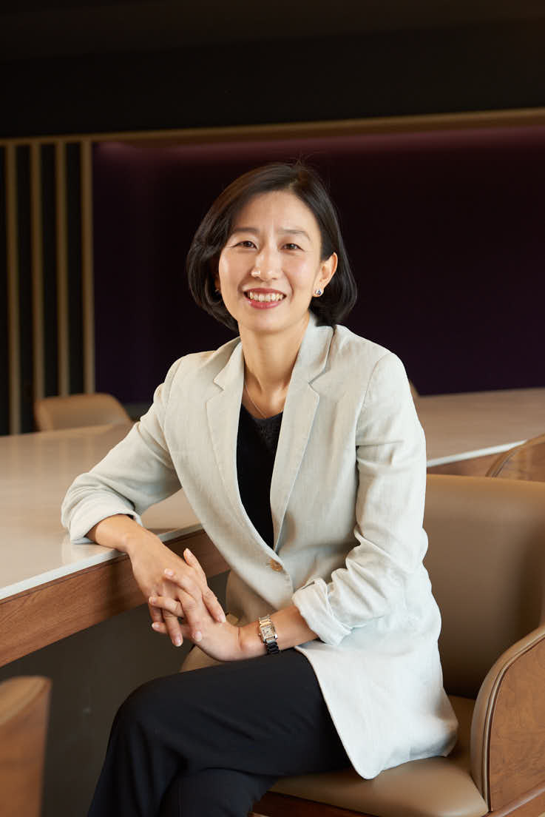

Professor Inyoung Cho is currently teaching Civil Law at Yonsei Law School. Prior to joining the Yonsei faculty, Prof. Cho has served as a judge for 17 years in various courts, including the International Transaction Chamber at Seoul Central District Court.  She joined the KCAB panel of international arbitrators in 2021.